Name: Stephanie Brown
Date: December 04, 2023
Title: Ways I am Smart

Bridge-in  15 min | Did you know there are different ways of being smart?  In 1983, Howard Gardner, Ph.D., presented his theory to the world… that humans have multiple intelligences. Through watching and studying humans for many years, Gardner discovered that all human beings have multiple intelligences in varying amounts… some more strong/preferred than others.  Gardner has identified 9 types of intelligences…  - Verbal/Linguistic {Word Smart}  - Logical/Mathematical {Logic Smart}  - Visual/Spatial {Image Smart}  - Interpersonal {People Smart}  - Intrapersonal {Self Smart}  - Bodily/Kinesthetic {Body Smart}  - Musical {Music Smart}  - Naturalist {Nature Smart}  - Spiritual/Existential {Spirit Smart} – This one is still under consideration.  Gardner didn’t believe one single test could measure how intelligent a person was…. The single intelligence test does not capture the full range of talents and abilities that humans possess.  ICE BREAKER – Multiples of copies of Handout 1: Challenges, cut up, and distributed around the table randomly.  You will notice that there are cut up challenges on the table. Please take up to 5 (minimum) different types of puzzles.  ~Note which ones are challenging for you and which ones are easiest.  Class Discussion to lead into the Pre-Assessment: Is there more than one way to be smart?  Reference Sheet 1: Challenges Solutions, pass around to learners once they have solved their Challenges to check their work.
Objective  5 min | Adult Learners will…  1) Know and identify their intelligences strengths and challenges.  2) Apply types of intelligences discovered to immediate learning goals.  3) Apply learned content to build confidence in their own abilities and strengths in adult learning.
Pre-assessment  30 min | Ice Breaker – Completed in “Bridge-In”.  Play Video – The 9 Types of Intelligences – What’s Your’s? (YouTube) – Link - https://youtu.be/ZDsbur594QA?si=3bzUOtxZheKtD4qD  Lead discussion after the video: Each of us has varying types of intelligences… Which 3 of the 9 Intelligences do you think will be your strongest? Which 3 do you think will be your weakest?
Participatory Learning  60 mins | Let’s Discover Our Ways of Being Smart!  {Materials that we are using today come from the Change it UP! Curriculum.}
Participatory Learning  60 mins | Time | Instructor Activities | Learner Activities | Lesson Resource
Participatory Learning  60 mins | 30mins  20 min | Distribute Handout 2 - Questionnaire –  Oral Instruction: Read out all the statements in each section of the survey.  Answer to how you it describes you today.  4 – really like me  3 – a lot like me  2 – a little like me  1 – not like me at all.  After finishing the Questionnaire…  ~ Add up your score for each of the 9 parts and write your total score in the Total Scores section.  Discussion: My Top 3 Strengths are… how will knowing your strengths help you in your adult learning? | Reading,  Writing  Read alone, then discuss with group | Handout  k
Post-assessment  10 mins | Remember the Challenges? Think back to which ones you found to be the easiest. Do they match with your strongest intelligence? Which ones would you like to further develop?
Summary/ Closure  5 min | Thank you for joining me today in discovering ‘Ways I’m Smart.’ Let me leave you with a little something for you to think about… What is one area in the 9 Intelligences that you would like to further develop? We will discover our Learning Styles next class and how our Intelligences work with our Learning Styles.

Handout 1 – Challenges

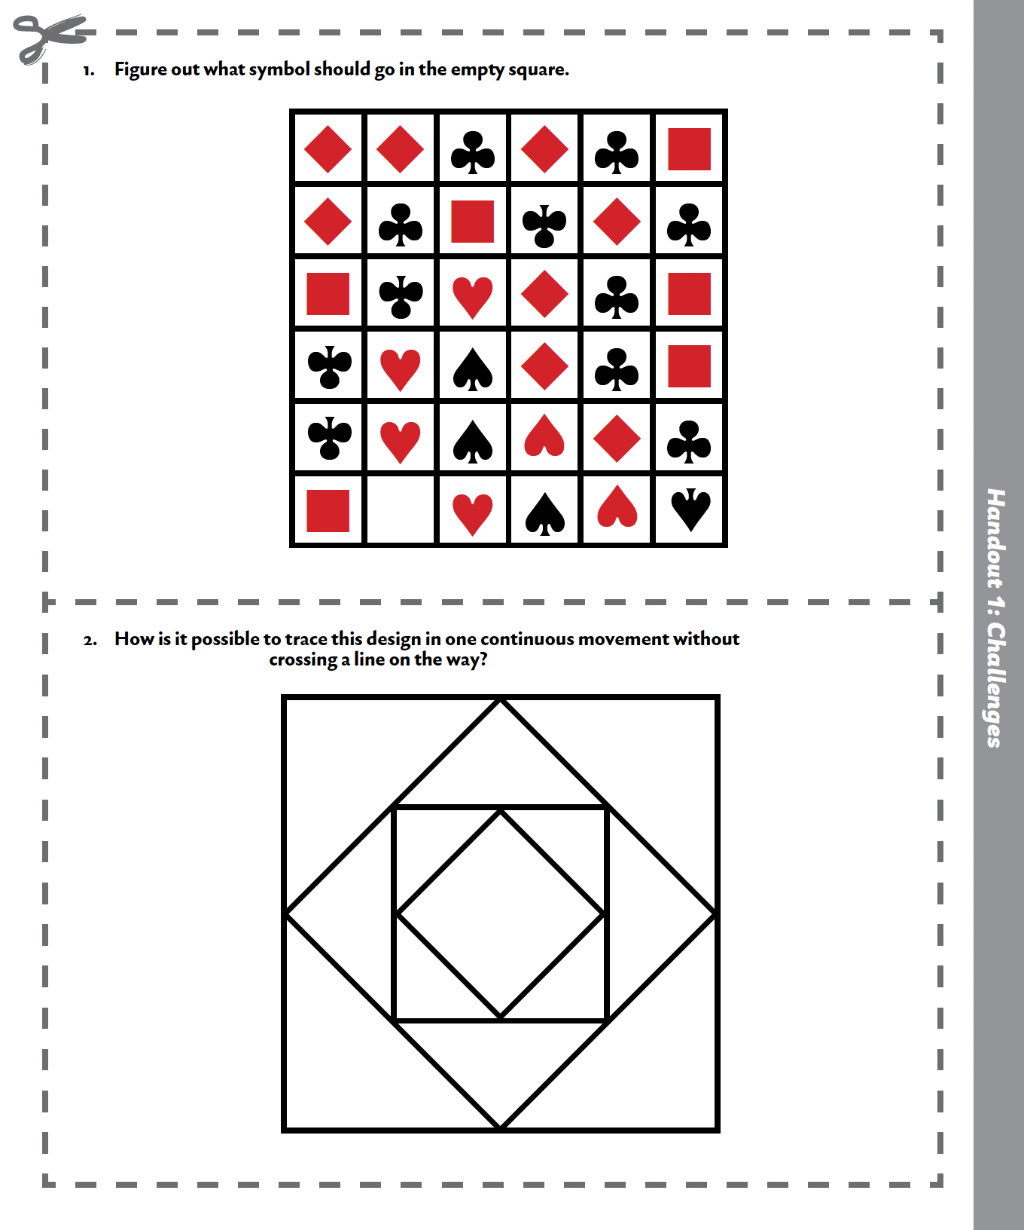

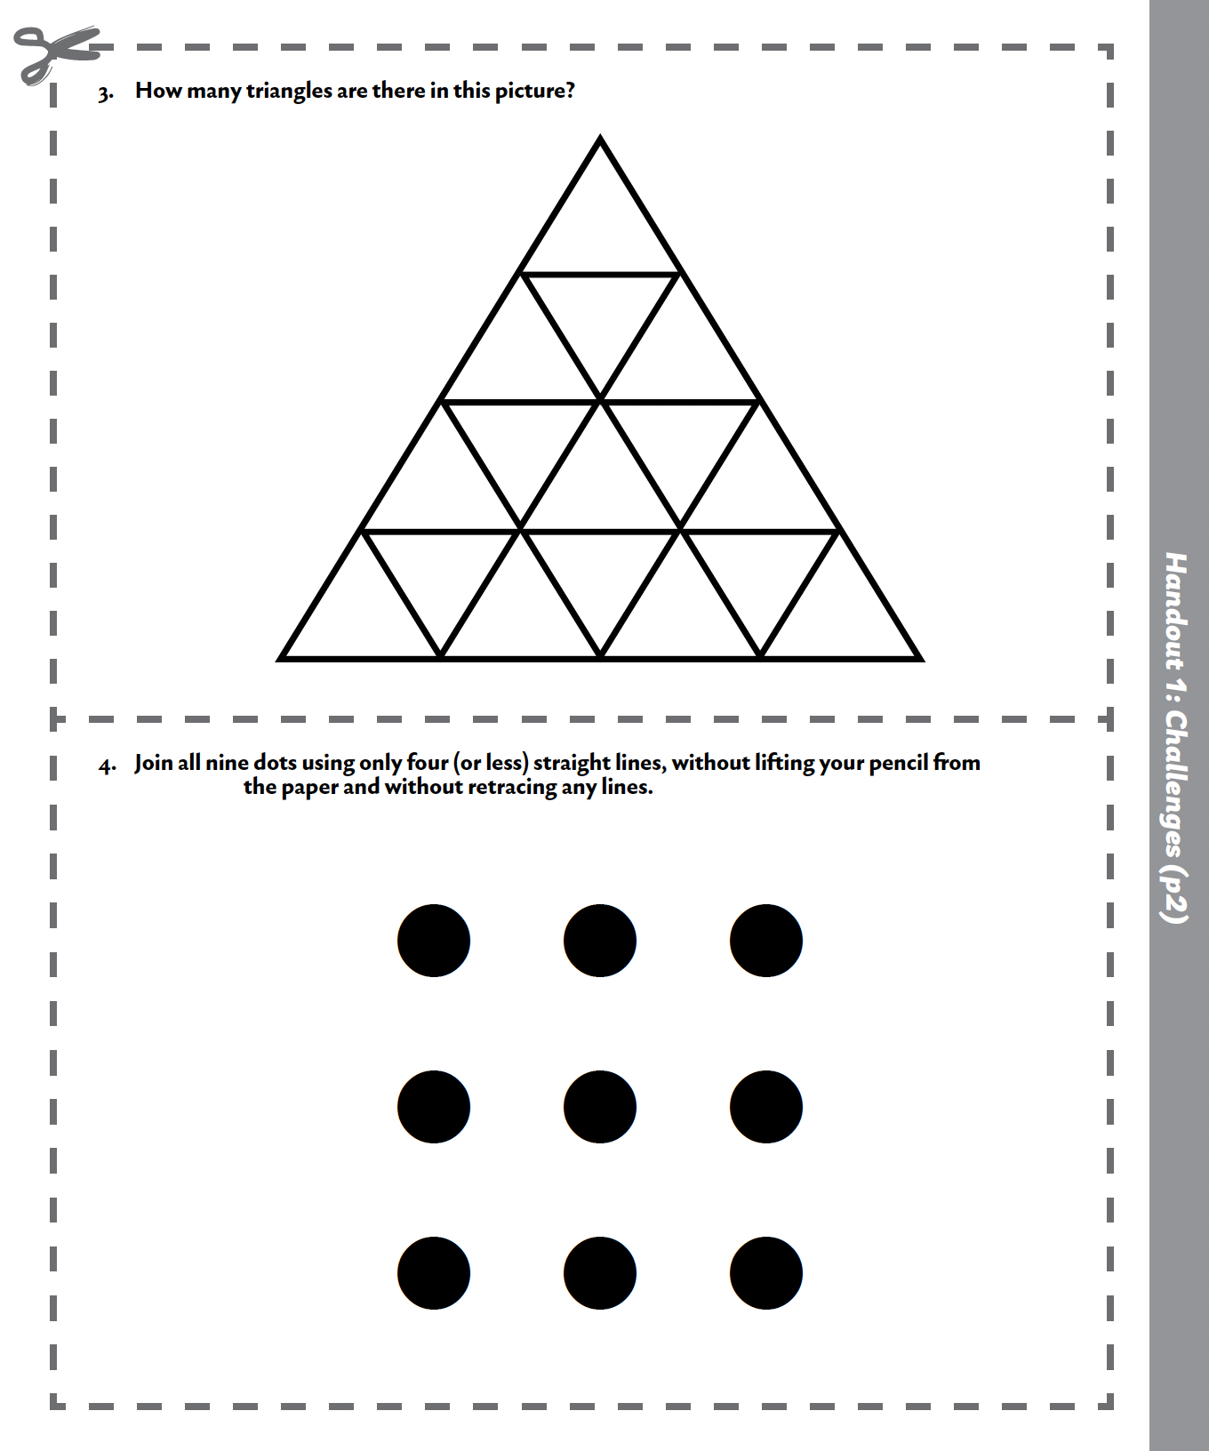

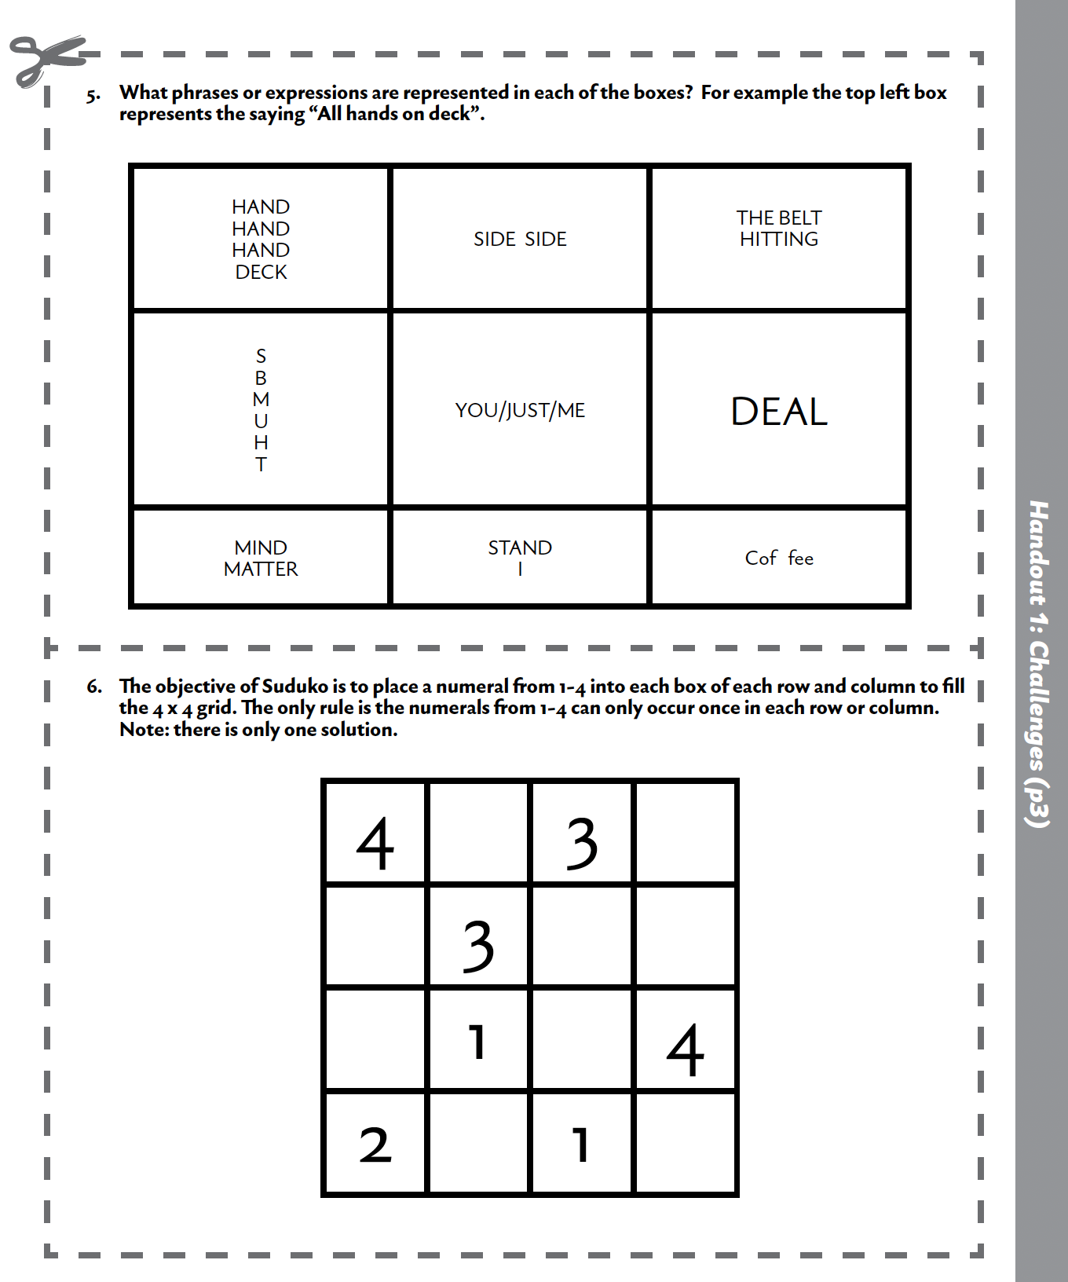

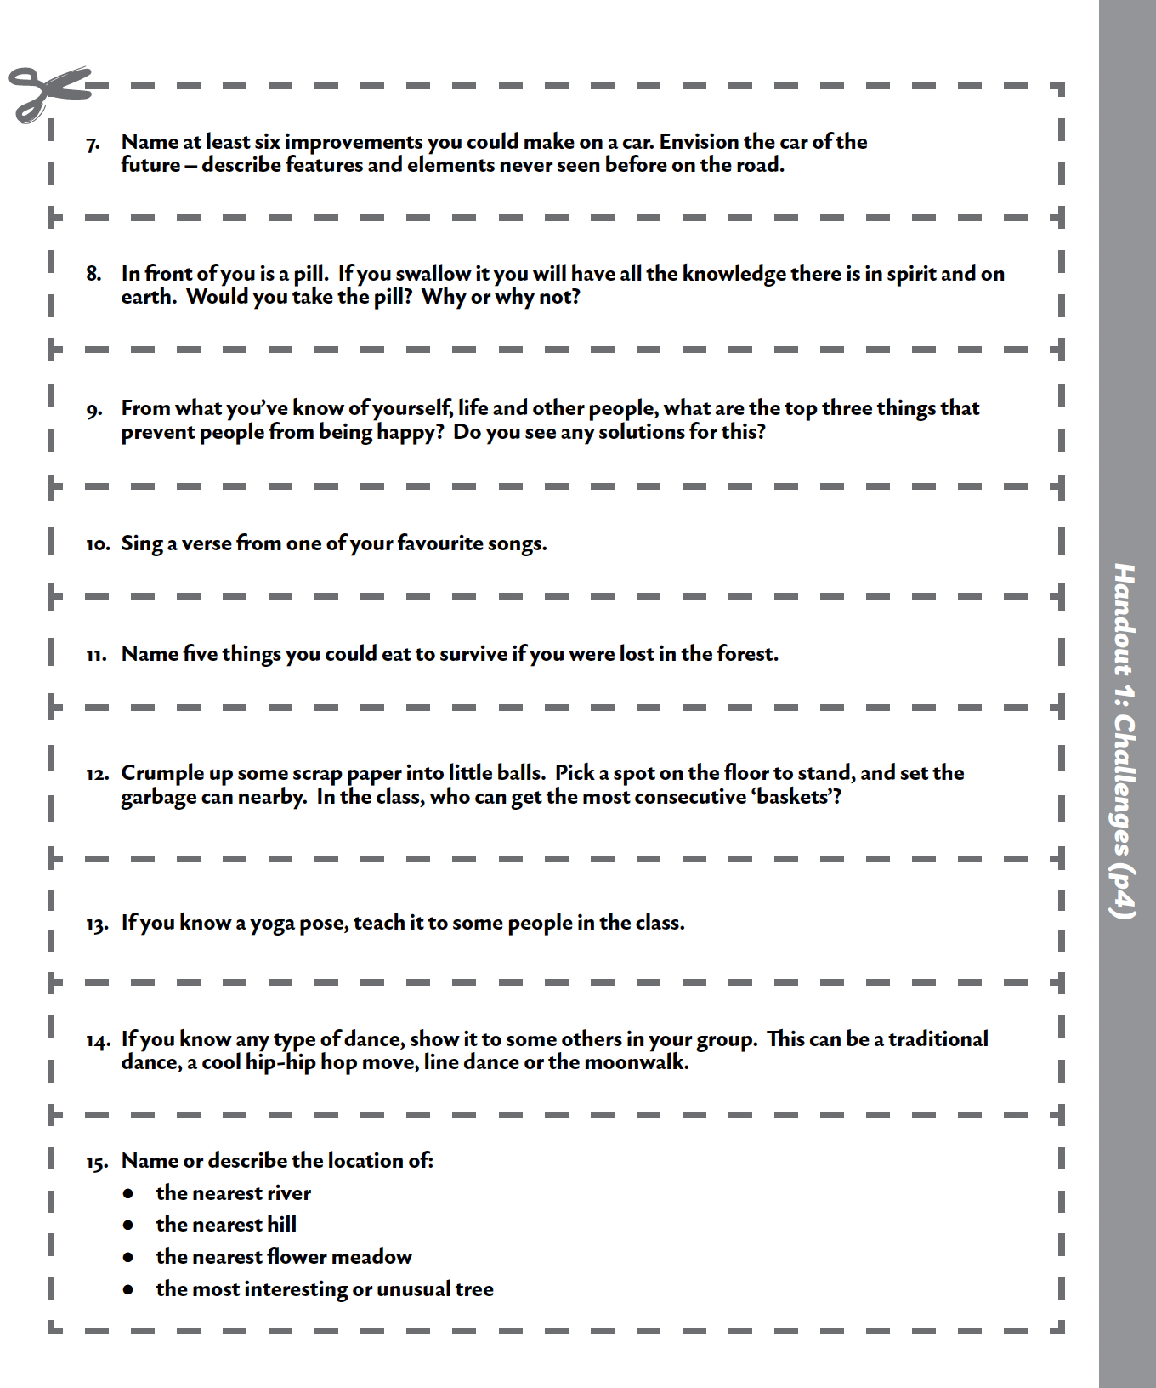
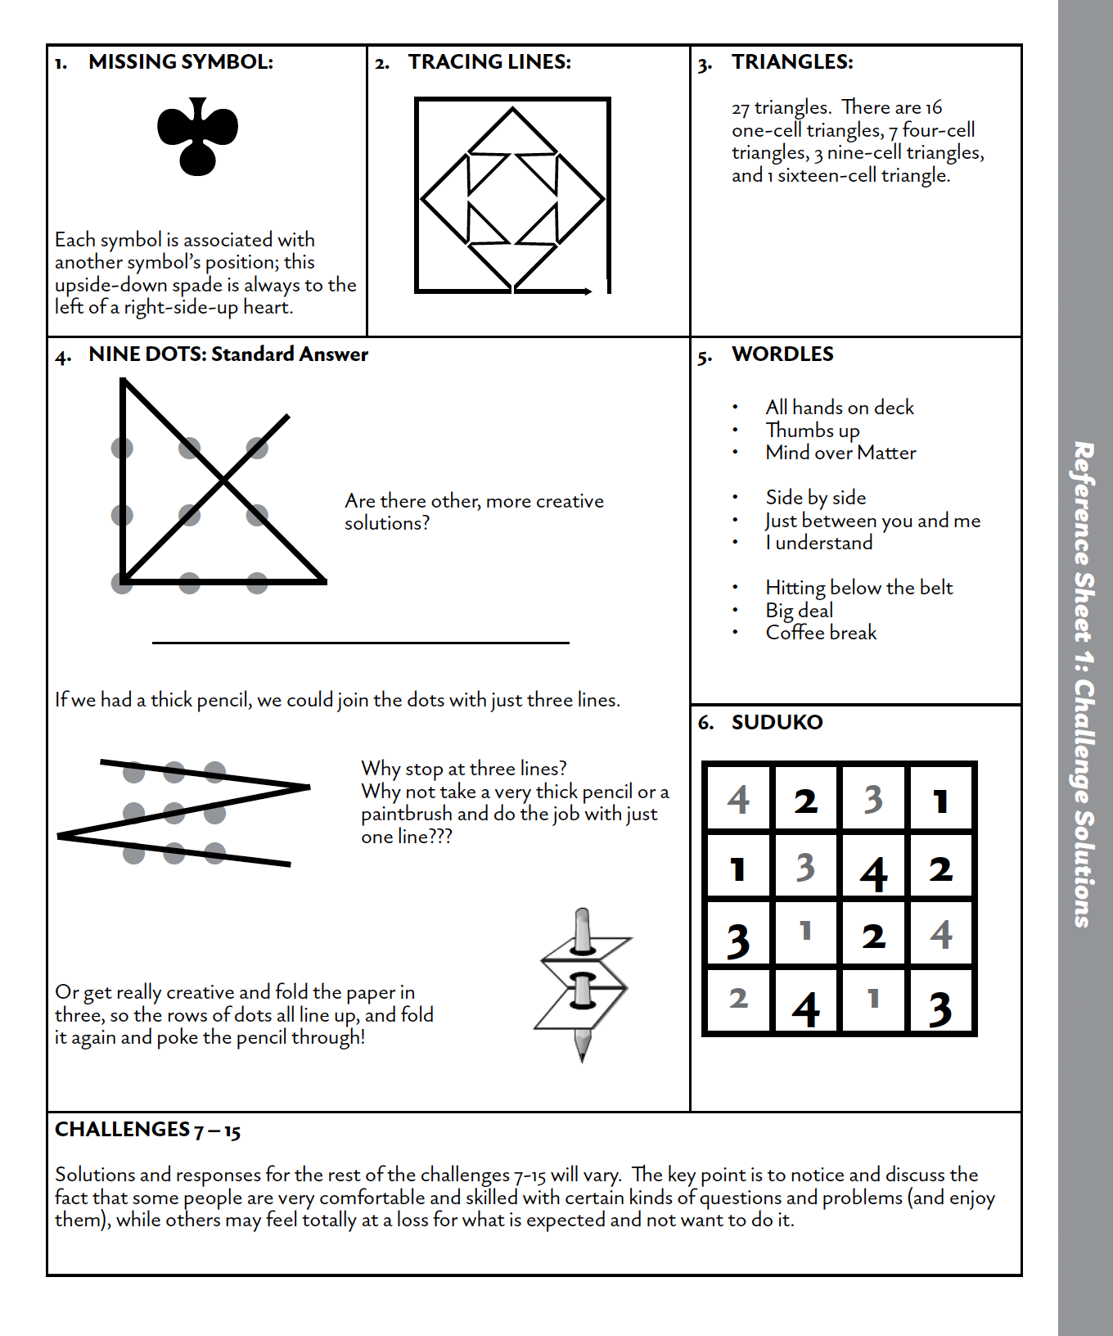

Handout 2



