CLN Support Services Overview
Community Learning Network (CLN) works in collaboration with and receives funding from the Government of Alberta to provide professional development and resources to organizations receiving a Community Adult Learning Program grant.
CLN provides the following supports and services to staff and boards of CALPs across Alberta:

Regional Support Network
CLN has full-time staff located regionally who are
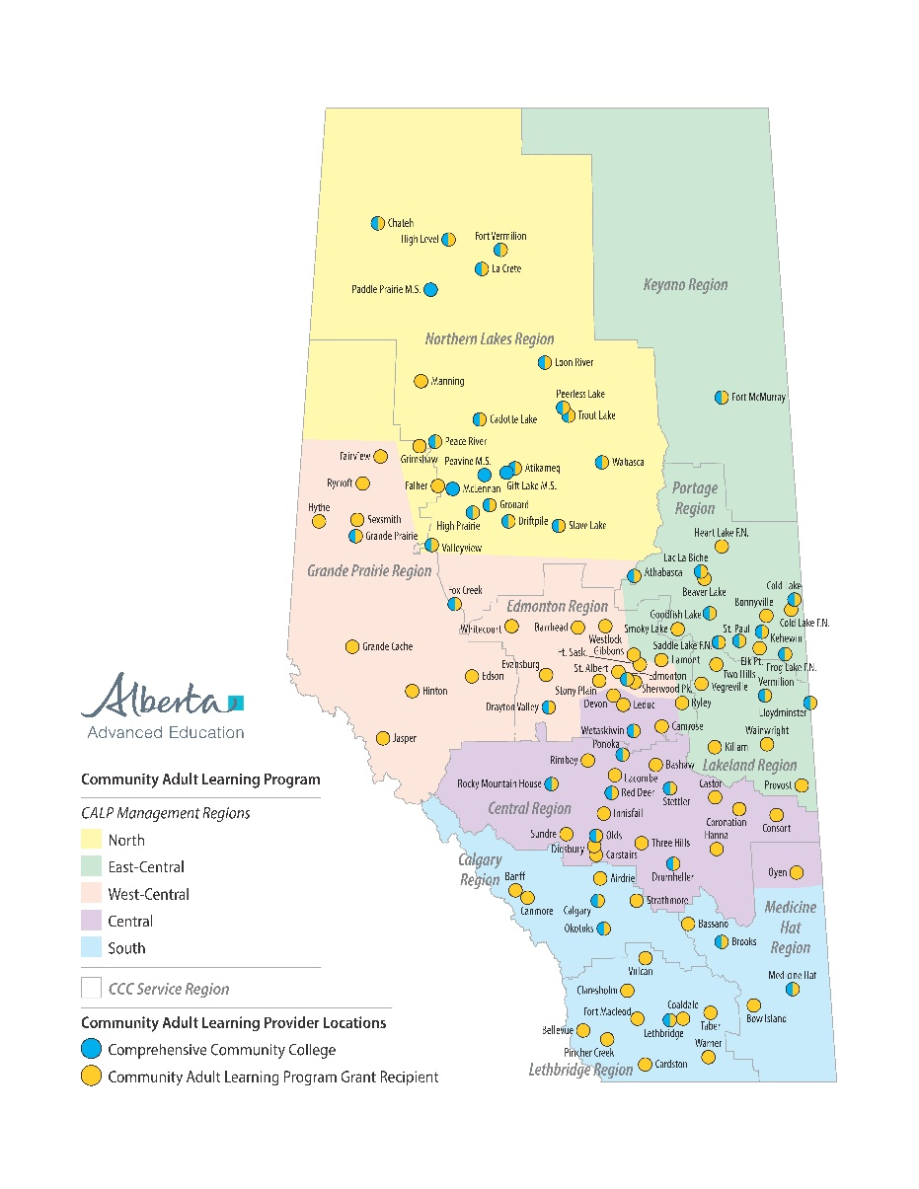
dedicated to providing customized support, mentoring and training.
CLN Staff are available to support you through in-person site visits, online, telephone and email.

Regional Support Staff:
north@calp.ca
east@calp.ca
west@calp.ca
central@calp.ca
south@calp.ca

Indigenous Liaison:
Faye.calp@gmail.com

Literacy Specialist:
literacy@calp.ca

Executive Director:

ed@calp.ca
Training Manager:
training@calp.ca

Professional Development and Training
CLN works closely with government, the provincial Professional Development Advisory Committee (PDAC), and CALPs in each region to identify and prioritize local training needs. Our team provides face-to-face,
online and blended training, networking, and other professional learning opportunities.
- CALP Grant Recipients
Comprehensive Community Colleges (CCC)

CALP Portal www.calp.ca
This is your “one-stop-shop” online for
information, resources, training opportunities, and connections with peers around Communities of Practice regionally and across the province.
To request a CALP Portal profile, complete the online form at https://calp.ca/user/request

Literacy & Learning Symposium
CLN’s annual Symposium features in-depth training opportunities, a wide variety of breakout sessions and inspiring keynote speakers. It also includes a CALP focused community of practice to support great opportunities to network and connect with colleagues from across the province.

PD and Events Specialist:
pdevents@calp.ca
Program Support:
office@calp.ca

CALP Database
CLN has developed a secure, customized database to help manage your program and learner data. The database will help you track data and generate reports for your CALP reporting requirements.
The CALP Database is free to CALPs who wish to use it.

CLN Provincial Office:
1-877-485-4926

